Problem 1
A hospital manages a queue of patient tokens. New critical patients must be added to the front,routine patients are added to the end, and occasionally a patient with a priority number must be inserted at a specific position in the queue. Given a sequence of such operations, implement all three insertion types and print the final queue after each operation. Describe how your insertion at a specific position works. What does your solution do if the position given is greater than the current length of the queue? Is that handled explicitly or does it cause an error?
Solution : #include<iostream> using namespace std; struct node
{
int info; node* link;
};

node* head=NULL;

void insertfront(int data)
{
node* temp=new node; temp->info=data;
temp->link=head; head=temp;
}

void insertend(int data)
{
node* temp=new node; temp->info=data;
temp->link=NULL;

if(head==NULL)
{
head=temp; return;
}

node* save=head;

while(save->link!=NULL)
{
save=save->link;
}

save->link=temp;
}

void insertpos(int data,int pos)
{
if(pos==1)
{
insertfront(data); return;

}

node* save=head;

for(int i=1;i<pos-1 && save!=NULL;i++)
{
save=save->link;
}

if(save==NULL)
{
cout<<"Invalid position"<<endl; return;
}

node* temp=new node; temp->info=data;
temp->link=save->link; save->link=temp;
}

void display()
{
node* save=head;

while(save!=NULL)
{
cout<<save->info<<" "; save=save->link;

}

cout<<endl;
}

int main()
{
int data,pos;

cout<<"Enter critical patient token: "; cin>>data;
insertfront(data); display();

cout<<"Enter routine patient token: "; cin>>data;
insertend(data); display();

cout<<"Enter priority patient token: "; cin>>data;

cout<<"Enter position: "; cin>>pos;

insertpos(data,pos); display();

return 0;
}

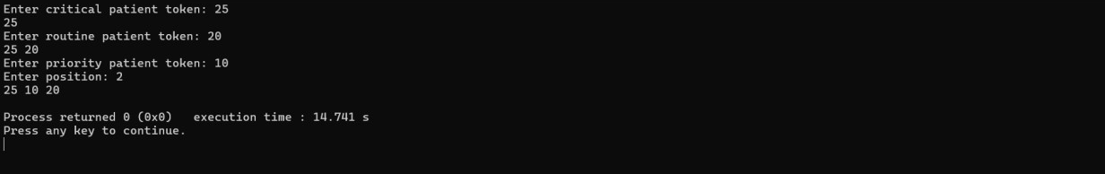
GITHUB LINK:

Problem 2
The hospital also needs to remove a patient token from the queue when a patient leaves, print
all remaining tokens from last to first for an end-of-day audit, and display the full queue from
front to back at any point. Implement deletion by value, reverse printing, and forward traversal
on the same queue from Problem 4.1a.
Describe how your reverse printing works. Does it use any extra storage, or does it work purely
by following the links? Can you think of another way to reverse-print without modifying the
original queue? SOLUTION:

#include<iostream> using namespace std;

struct node
{
int info; node* link;
};
node* head=NULL;

void insertend(int data)
{
node* temp=new node; temp->info=data;
temp->link=NULL; if(head==NULL)
{
head=temp; return;
}
node* save=head; while(save->link!=NULL)
{
save=save->link;
}
save->link=temp;
}

void deletevalue(int data)

{
if(head==NULL) return;
if(head->info==data)
{
node* temp=head; head=head->link; delete temp; return;
}
node* save=head;
while(save->link!=NULL&&save->link->info!=data)
{
save=save->link;
}
if(save->link==NULL) return;
node* temp=save->link; save->link=temp->link; delete temp;
}

void display()
{
node* save=head; while(save!=NULL)
{
cout<<save->info<<" "; save=save->link;

}
cout<<endl;
}

void reverseprint(node* save)
{
if(save==NULL) return;
reverseprint(save->link); cout<<save->info<<" ";
}

int main()
{
int n,data;
cout<<"Enter number of patients: "; cin>>n;
for(int i=0;i<n;i++)
{
cin>>data; insertend(data);
}
cout<<"Queue: "; display();
cout<<"Enter token to delete: "; cin>>data;
deletevalue(data); cout<<"Queue after deletion: "; display();

cout<<"Reverse queue: "; reverseprint(head); return 0;
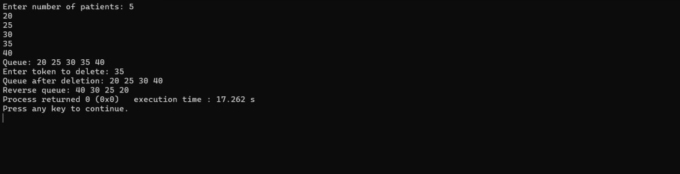
}

GITHUB LINK:

